Lab manual 10

Name: Syed Muhammad Hassaan

Roll no: 460991

Task 1:

1. #include<iostream>
2. #include<vector>
3. using namespace std;
5. int main(){
6. int input, i;
7. vector<int> v;
8. for(i=0; i<10; i++){
9. cout<<"Enter a Value to Push into Vector's "<<i<<" index: ";
10. cin>>input;
11. v.push_back(input);
12. }
13. cout<<endl<<"Vector Currently Holding: ";
14. for(i=0; i<10; i++)
15. {
16. cout<<v.at(i)<<", ";
17. }
18. v.erase(v.begin()+5);
19. v.insert(v.begin()+5, 5);
20. cout<<endl<<"Updated Vector: ";
21. for(i=0; i<10; i++)
22. {
23. cout<<v.at(i)<<", ";
24. }
26. }
27. 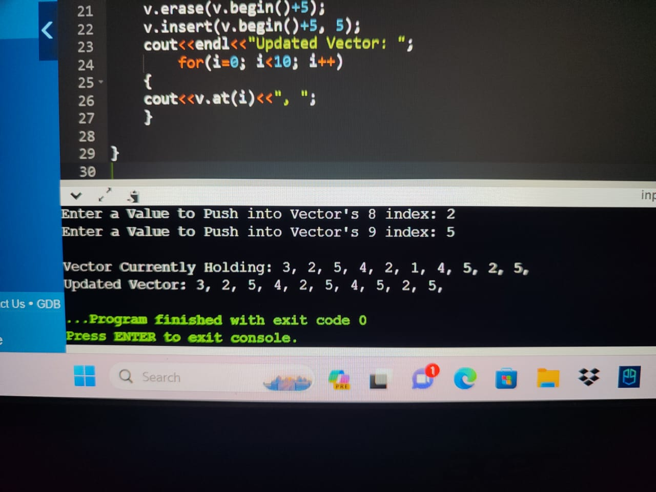

Task 2:

1. #include<iostream>
2. #include<vector>
3. #include<string>
4. using namespace std;

7. int find_mean(vector<int> v){
8. int sum=0, size=v.size();
9. for(int i=0; i<v.size(); i++){
10. sum=v[i]+sum;
11. }
12. int mean=sum/v.size();
13. return mean;
14. }
15. int find_median(vector<int> v){
16. int i, j, temp, median;
17. for(i=0; i<v.size()-1; i++){
18. for(j=0; j<v.size()-1; j++){
19. if(v[j]>v[j+1]){
20. temp=v[j];
21. v[j]=v[j+1];
22. v[j+1]=temp;
23. }
24. }
25. }
26. int n=v.size();
27. if(n%2 == 0){
28. median=((n/2)+((n/2)+1))/2;
29. }
30. else{
31. median=(n+1)/2;
32. }
34. return v[median-1] ;
35. }
37. int find_mode(vector<int> v){
38. int repetition=0, maxrep=0, mostrepeated;
39. for(int i=0; i<v.size(); i++){
40. repetition=0;
41. for(int j=0; j<v.size(); j++){
42. if(v[i]==v[j]){
43. repetition++;
44. }
45. }
46. if(repetition>maxrep){
47. maxrep=repetition;
48. mostrepeated=v[i];
49. }
50. }
51. return mostrepeated;
52. }
54. void students_mode(vector<string> v, vector<int> g, int mode){
55. int i=0;
56. cout<<"Students with Grade Equal to Mode: ";
57. for(i=0; i<v.size(); i++){
58. if(g[i]==mode){
59. cout<<v[i]<<endl;
60. }
61. }
62. }
63. int main(){
64. vector<string> names;
65. vector<int> grades;
66. int i,j,input, num;
67. string name;
68. cout<<"Enter Number of Students to be Inputted: ";
69. cin>>num;
70. for(i=0; i<num; i++){
71. system("cls");
72. cout<<"Enter the Name of Student: ";
73. cin>>name;
74. names.push_back(name);
75. cout<<endl<<"Enter Grade of Student in Percentage: ";
76. cin>>input;
77. grades.push_back(input);
78. }
79. system("cls");
80. int mean=find_mean(grades);
81. cout<<endl<<"Mean is: "<<mean<<endl;
82. int median=find_median(grades);
83. cout<<"Median is: "<<median<<endl;
84. int mode=find_mode(grades);
85. cout<<"Mode is: "<<mode<<endl;
86. students_mode(names, grades, mode);
87. }
88. 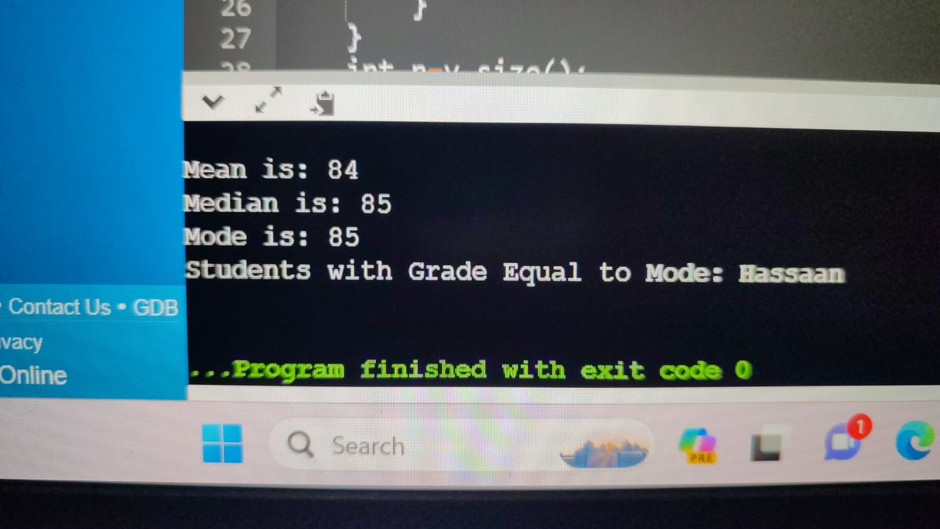

Task 3:

1. #include<iostream>
2. #include<cmath>
3. using namespace std;
5. class triangle{
6. public:
7. int length1=3;
8. int length2=4;
9. int length3=5;
10. int perimeter(){
11. return length1+length2+length3;
12. }
13. double area(){
14. int area,s;
15. s=perimeter()/2;
16. return sqrt(s * (s - length1) * (s - length2) * (s - length3));
17. }
18. };
20. int main(){
21. triangle task3;
22. int perimeter;
23. double area;
24. perimeter=task3.perimeter();
25. area=task3.area();
26. cout<<"Area is: "<<area<<endl;
27. cout<<"Perimeter is: "<<perimeter<<endl;
28. }
29. 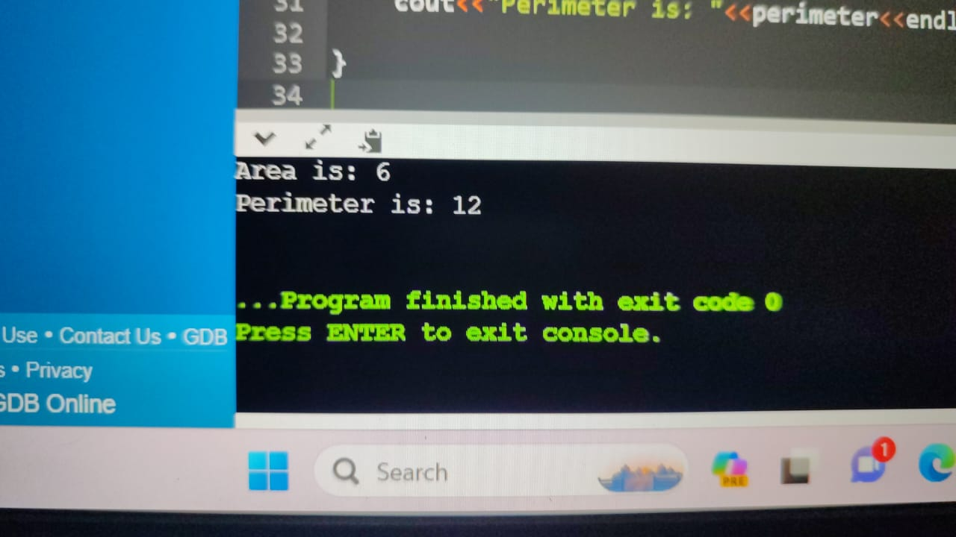

Task 4:

1. #include <iostream>
2. #include <string>
4. using namespace std;
6. struct Employee {
7. string name;
8. double salary;
9. int hoursWorkedPerDay;
10. };
12. int main() {
13. const int numEmployees = 10;
14. Employee employees[numEmployees];
16. for (int i = 0; i < numEmployees; ++i) {
17. cout << "Enter name for employee " << i + 1 << ": ";
18. cin >> employees[i].name;
20. cout << "Enter salary for employee " << i + 1 << ": ";
21. cin >> employees[i].salary;
23. cout << "Enter hours of work per day for employee " << i + 1 << ": ";
24. cin >> employees[i].hoursWorkedPerDay;
26. cout << endl;
27. }
29. for (int i = 0; i < numEmployees; ++i) {
30. if (employees[i].hoursWorkedPerDay >= 12) {
31. employees[i].salary += 150;
32. } else if (employees[i].hoursWorkedPerDay >= 10) {
33. employees[i].salary += 100;
34. } else if (employees[i].hoursWorkedPerDay >= 8) {
35. employees[i].salary += 50;
36. }
37. }
38. 